**PAYROLL**

**MANAGEMENT SYSTEM**

**Introduction to Payroll Management System**

The "Payroll Management System" has been developed to override the problems prevailing in the practicing manual system. This software is supported to eliminate and in some cases reduce the hardships faced by this existing system. Moreover this system is designed for the particular need of the company to carry out operations in a smooth and effective manner.

The application is reduced as much as possible to avoid errors while entering the data. It also provides error message while entering invalid data. No formal knowledge is needed for the user to use this system. Thus by this all it proves it is user-friendly. Payroll Management System, as described above, can lead to error free, secure, reliable and fast management system. It can assist the user to concentrate on their other activities rather to concentrate on the record keeping. Thus it will help organization in better utilization of resources.

Every organization, whether big or small, has challenges to overcome and managing the information of Employee Salary, Employee, Department, Payroll, Payslip. Every Payroll Management System has different Employee needs, therefore we design exclusive employee management systems that are adapted to your managerial requirements. This is designed to assist in strategic planning, and will help you ensure that your organization is equipped with the right level of information and details for your future goals. Also, for those busy executive who are always on the go, our systems come with remote access features, which will allow you to manage your workforce anytime, at all times. These systems will ultimately allow you to better manage resources.

### purpose of this project:

Main aim of developing Payroll Managementis to provide an easy way not only to automate

all functionalities involved managing leaves and Payroll for the employees of Company, but also to provide

full functional reports to management of Company with the details about usage of leave facility.

### We are committed to bring the best way of management in the various forms of Payroll Management System ****.**** We understand that ****PMS**** in not a product to be sold, it is a tool to manage the inner operation of Company related to employee leave and Payroll.

### Features of Payroll System:

**These are the important features of the project payroll Management System:**

* It contain better storage capacity.
* Accuracy in work.
* Easy & fast retrieval of information.
* Well designed reports.
* Decrease the load of the person involve in existing manual system.
* Access of any information individually
* Work becomes very speedy.
* Quickly find out information of an employee details.
* Easy to update information.

### Modules:

### Admin: The Admin gets logged in by valid username and password. Admin can add new Employee, add new Department, add new Positions for the employees. Admin can set the ‘from’ and ‘to’ date worked by an employee in a department with specific positions. The Admin can generate an automated monthly salary of an employee. The admin can view all the past records of any recorded employees . The admin can watch the dashboard which shows the information about employees like late employee today on time employees today and total number of employees also a bar graph indicating the on time and late employees of every month

**Advantages:**

• It is cost effective as the user control the web application himself and does not go for professional service.

• It saves time as it speeds up every aspect of the employee database management and payroll process

with a range of automated features.

• It is secure as the employee database and the payroll process is managed by the admin in house rather

than sending private information to a third party.

• Validating procedures and checks restrict user from making mistakes.

• The software is easy to use and is user friendly so no expertise is required.

• The calculations are automated so no chance of error.

**Disadvantages:**

• It requires an internet connection.

• It requires large database.

### Feasibility Study:

After identifying the scope of the project, the feasibility study is needed to be carried out. It is basically keeping the following points in mind .

Feasibility study includes consideration of all the possible ways to provide a solution to the given problem. The proposed solution should satisfy all the user requirements and should be flexible enough so that future changes can be easily done based on the future upcoming requirements.

1. **Technical Feasibility**

This software is very much technically feasible. This software is very much concerned with specifying equipment and the software will successfully satisfy almost all the admin’s requirements. The technical need for this system may vary considerably but might include:

1. The facility to produce output in a given time.
2. Response time under certain conditions.

c. Ability to process data at a particular speed.

Therefore, the basic input/output of data is identified. So, the project can easily be build up and it will also be technically feasible.

1. **Financially Feasibility**

The project is very much financially feasible. The implementation and development cost of this software under the reach of any college. Moreover, it requires some training for the use. So, training cost can be neglected and the resources of this software are very much available. It also reduces the labour and extra cost to be paid for labour. So indeed, it is financially feasible.

1. **Operational Feasibility**

No doubt the proposed system is fully GUI based that is very user friendly and all inputs to be taken all self-explanatory even to a layman. Besides, a proper training has been conducted to let know the essence of the system to the users so that they feel comfortable with new system. As far our study is concerned the clients are comfortable and happy as the system has cut down their loads and doing.

### System Requirements:

**Software Requirement:**

* + Apache Server 2.0
  + PHP Version 5.3 or above
  + MySQL Version 5.5 or above
  + Latest browser : Chorme, Firefox, Safari etc
  + Operating System : Any (Linux, Windows, Mac etc)

**Hardware Requirements:**

* + Processor Pentium IV or higher version.
  + Ram 128 MB or above
  + Hard Disk 150 MB or above

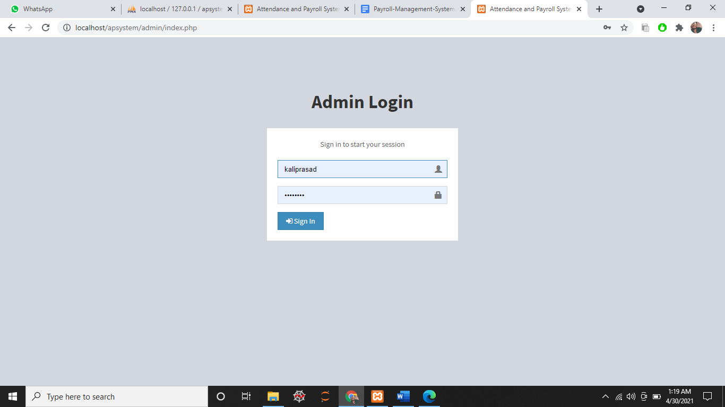 **Admin Login**

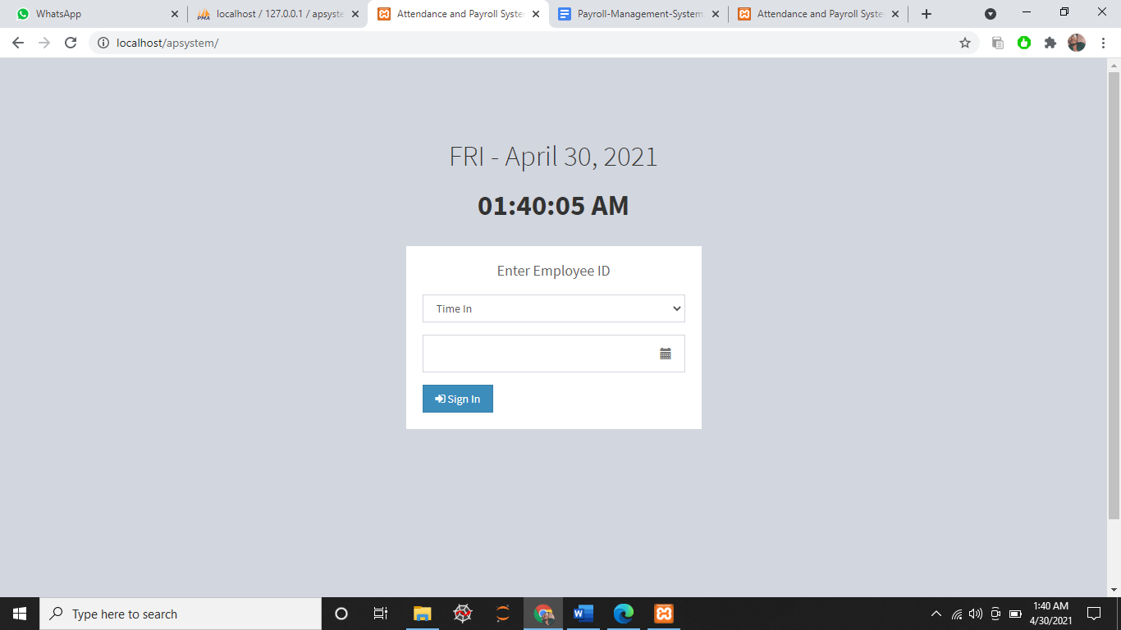

**Employee Login**

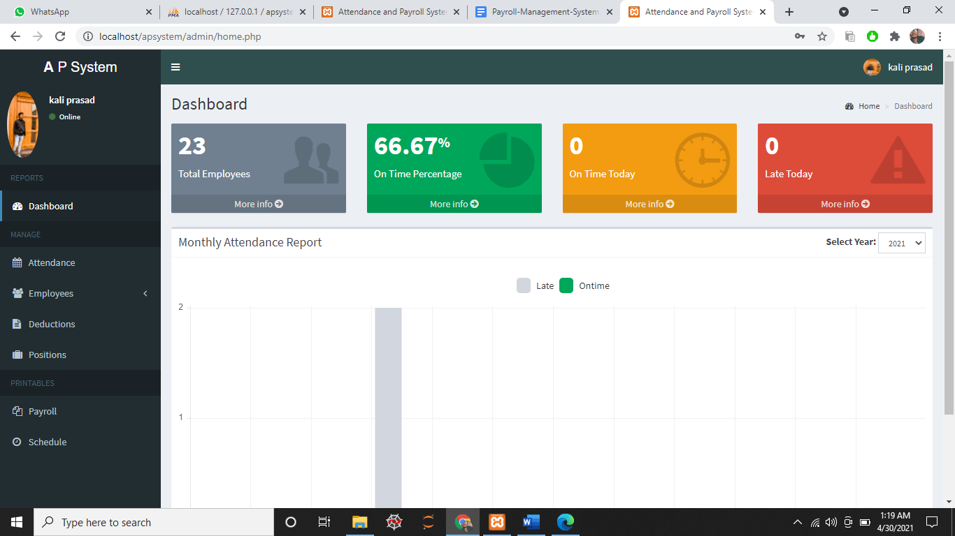

**Admin Interface**

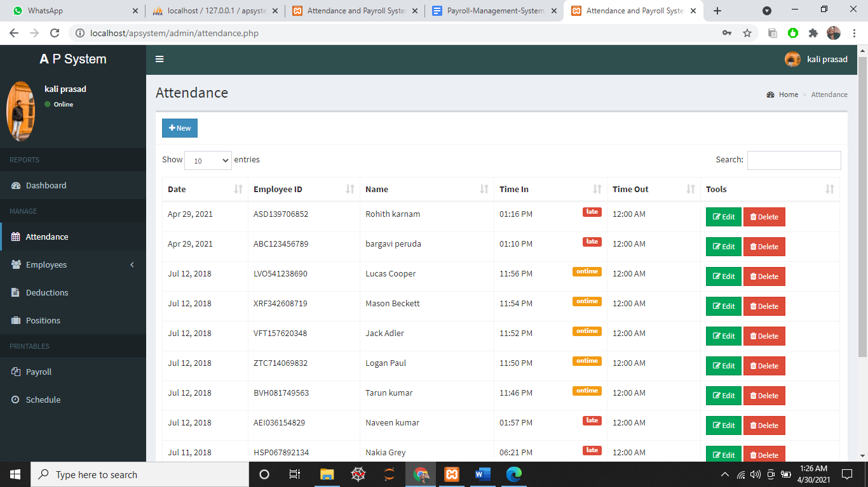

Attendance view

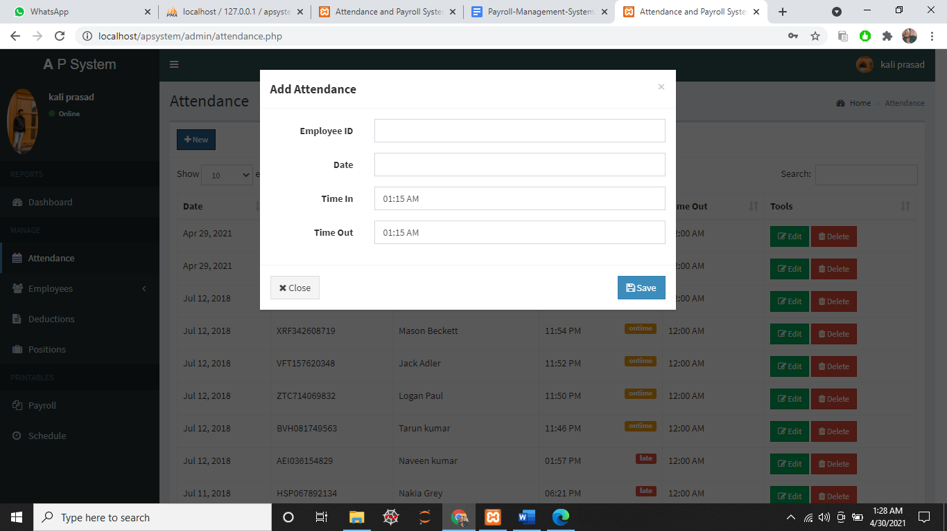

AddAttendance

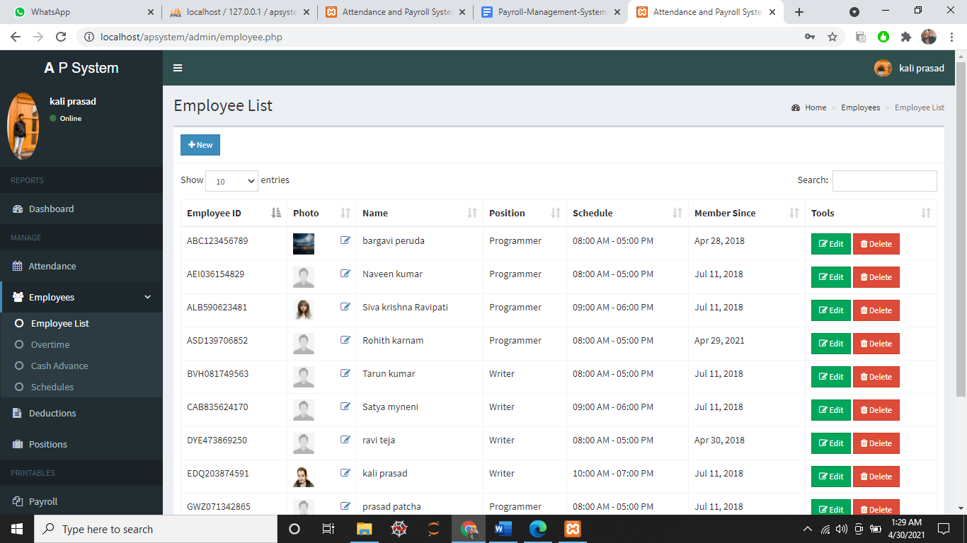

**Employee List**

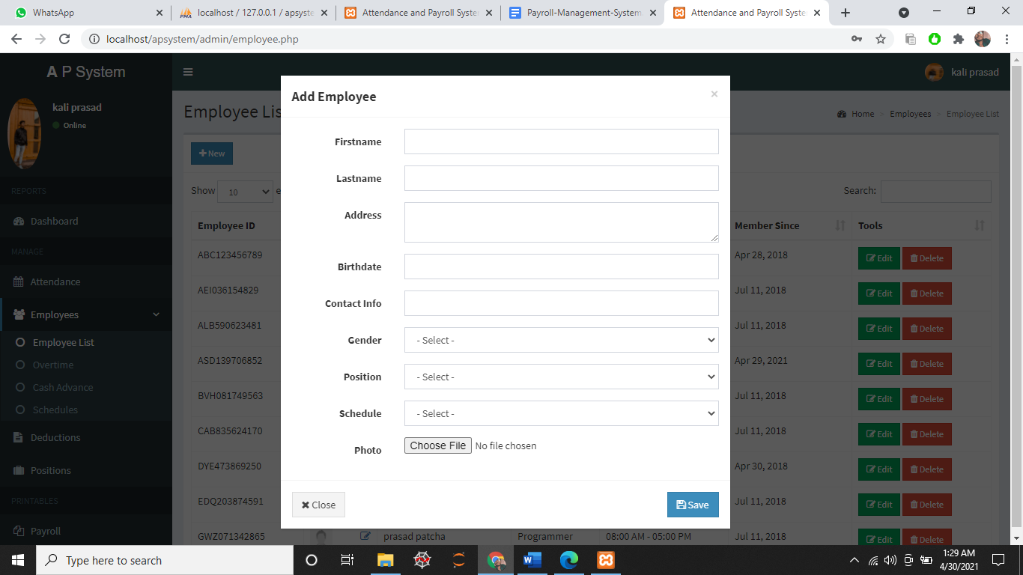

**Add Employee**

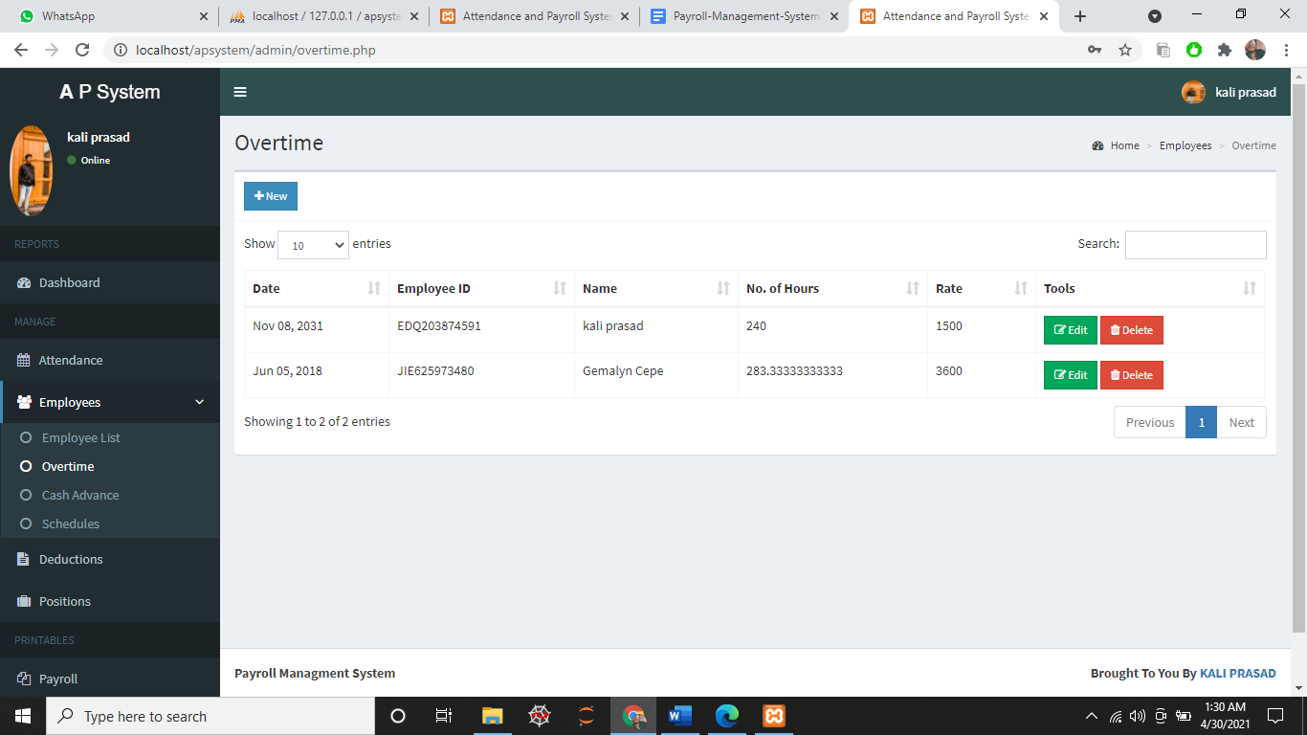

**Overtime workers**

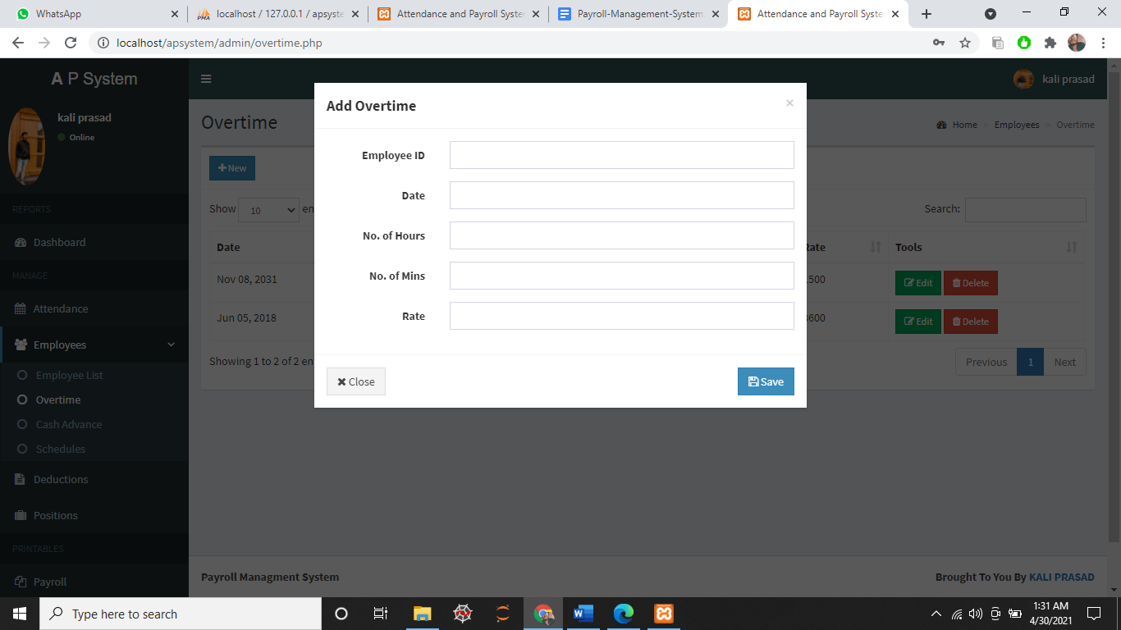

**Add Overtime workers**

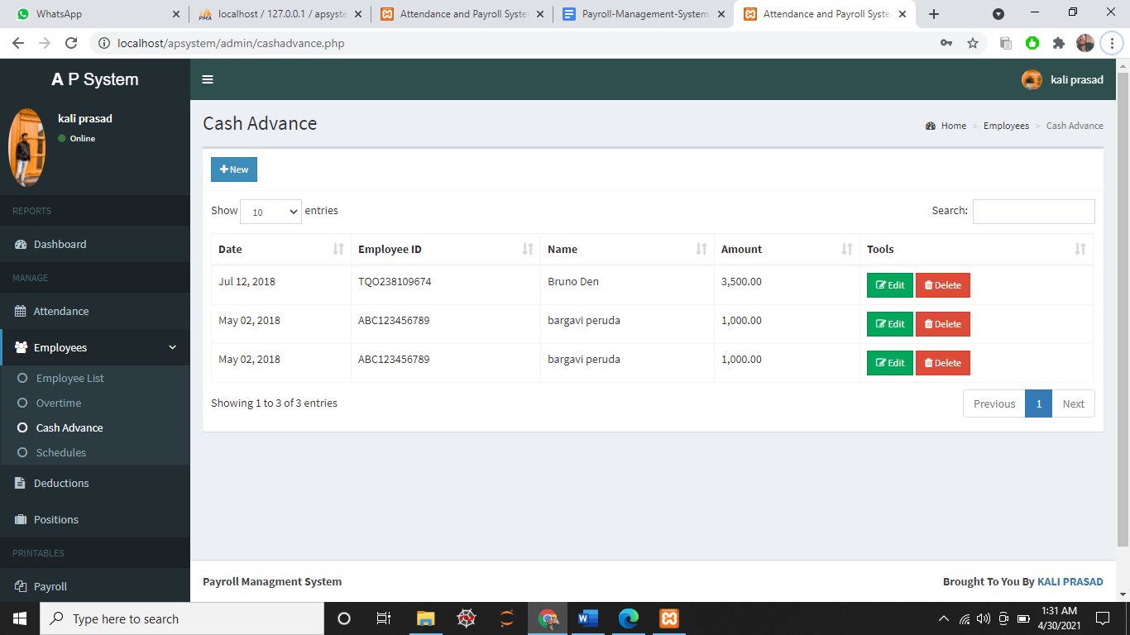

**Cash advance**

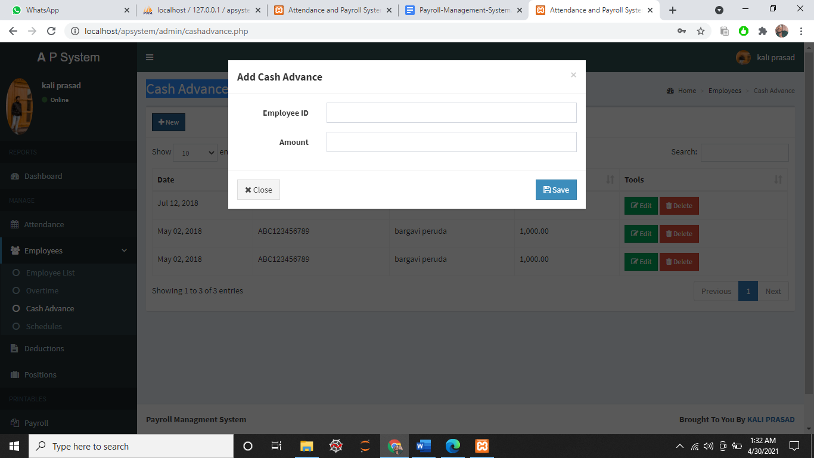

Add cash advance

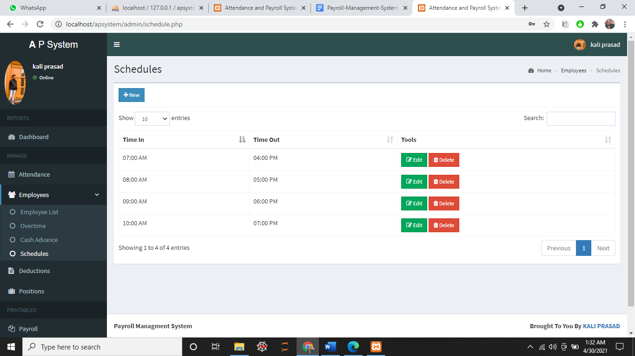

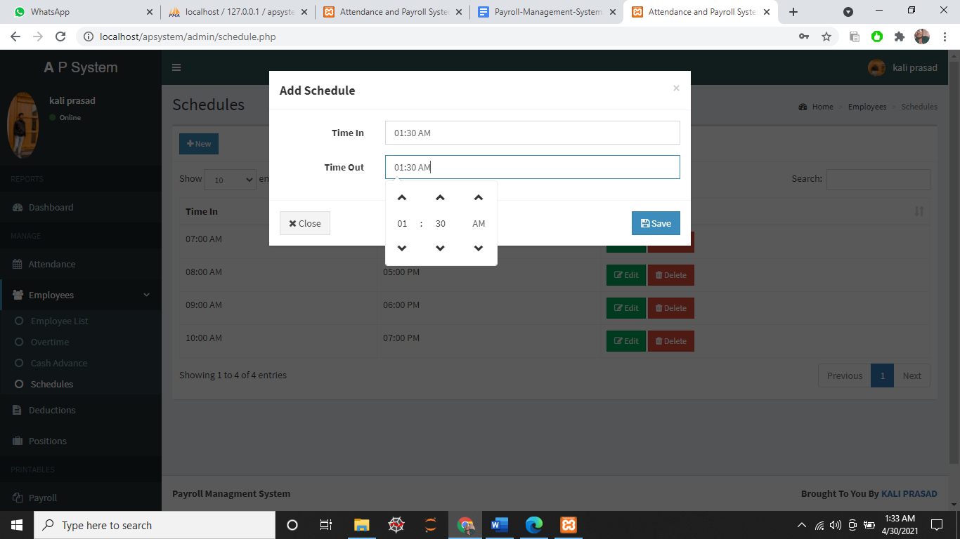**Schedules (shifts)**

**Adding Schedules**

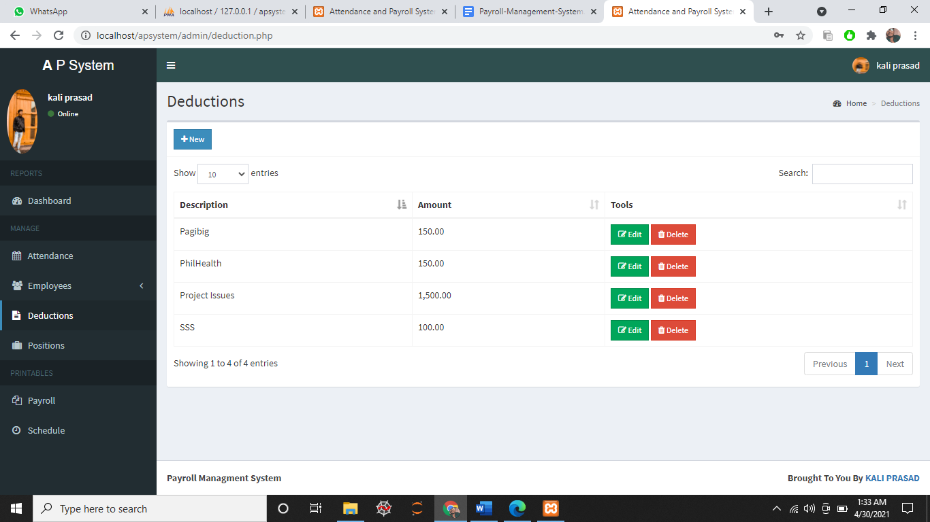

**Deductions of salary**



**Employee list**

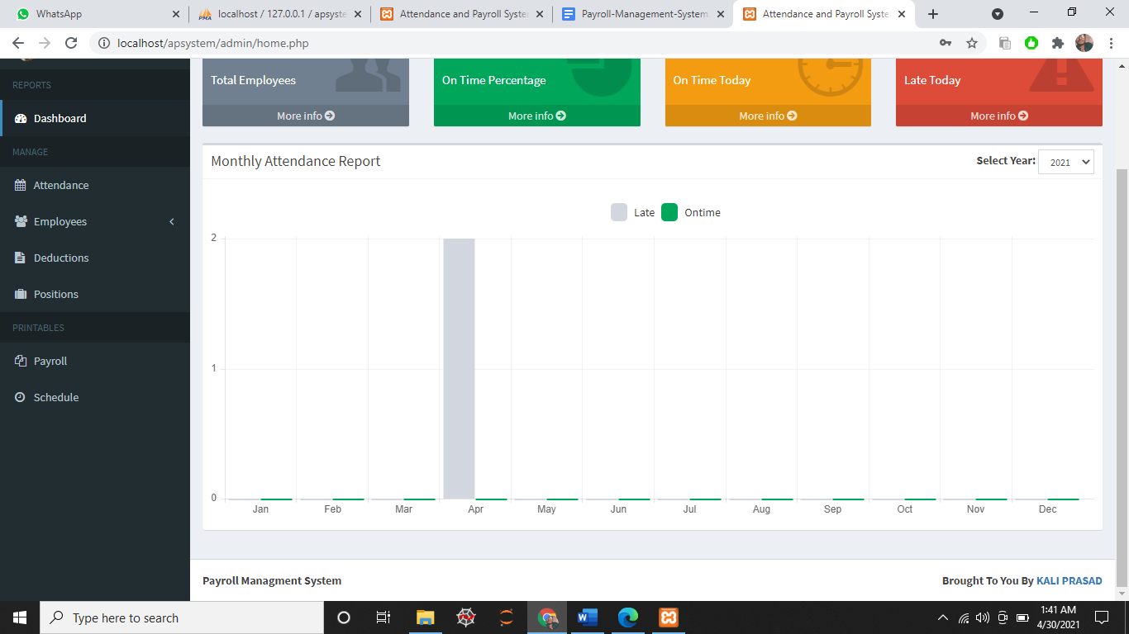

**Monthly attendance report**



**Overtime work**

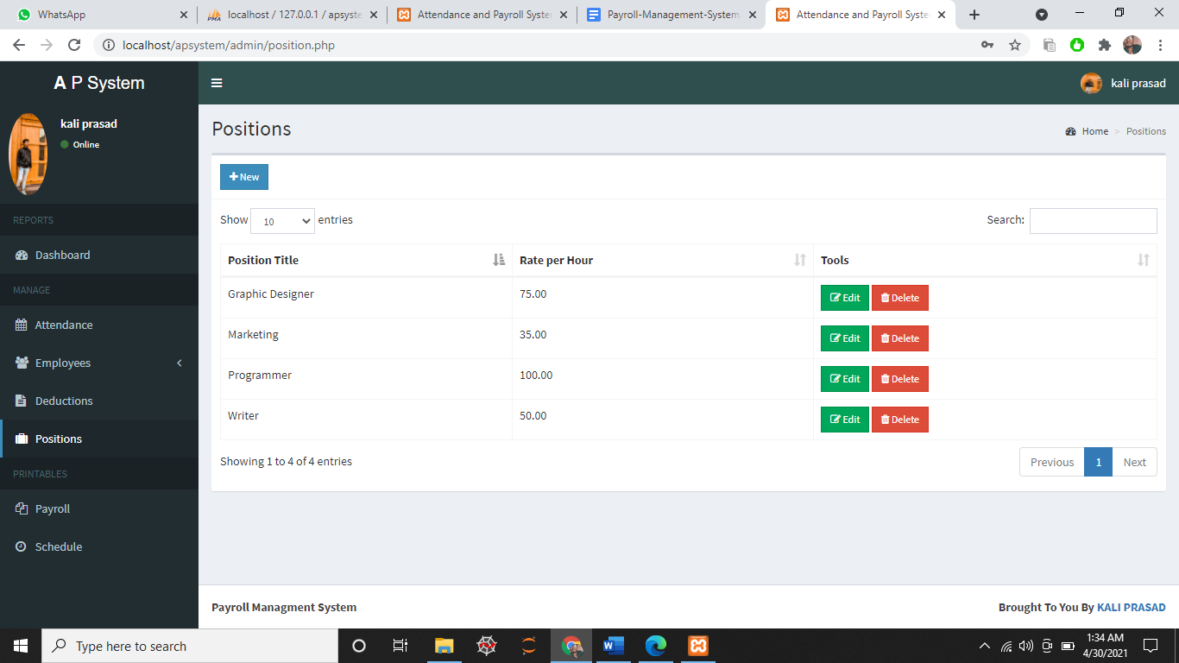

**Positions (roles)**

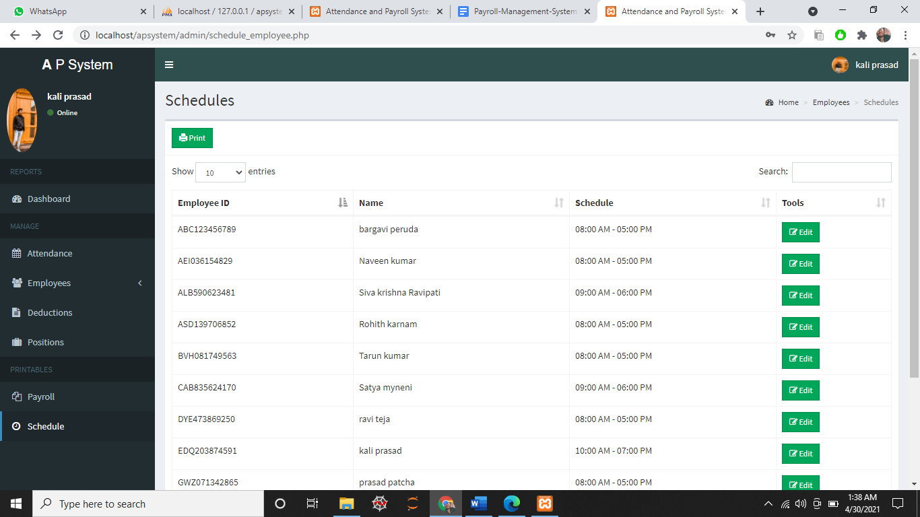

**Schedules with all employees**

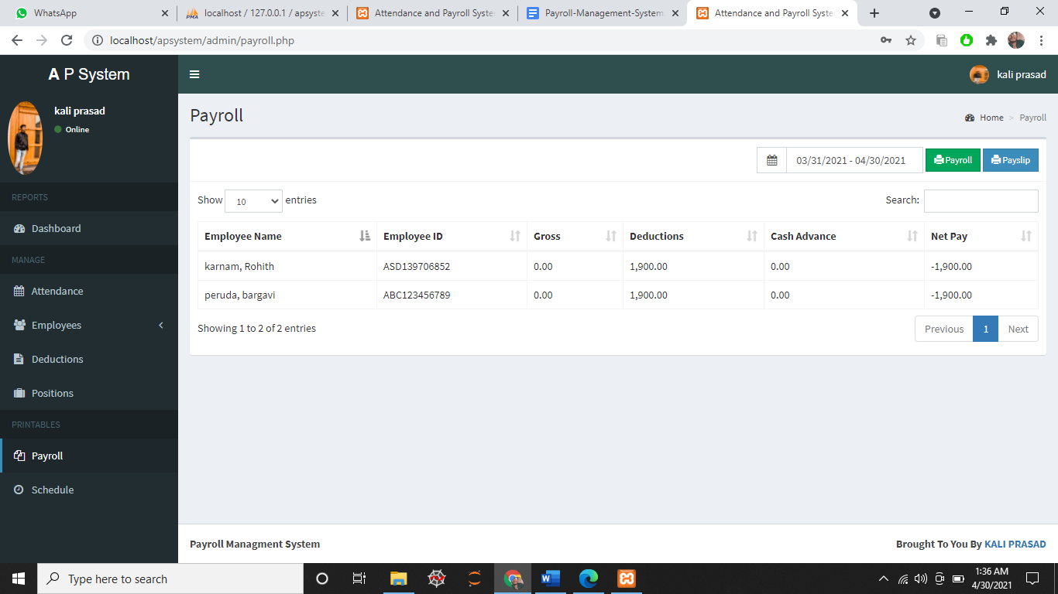

**Payroll**

**Tables of the Projects**

* + **Login : Contains the login information details**
  + **Dashboard : Contains total employee, on time percentage ,on time . today , late today and a bar graph**
  + **Employee list : Contains the data about the employee**
  + **Deduction : Contains the Information about deducted money**
  + **overtime : Contains the information about overtime workers**
  + **positions : Contains the role of the employee**
  + **payroll : Contains the payroll and payslip of employee**
  + **Attendance : Cv ontains the attendance details of employee**
  + **schedules : Contains shifts that workers should work**

# Use case Diagram for Payroll Management System:

# A use case diagram in the Unified Modeling Language(UML) is a type of behavioral diagram defined by and created from a use-case analysis.its purpose is to present a graphical overview of the functionality provided by a system in terms of actors, their goals,and any dependencies between those use cases. Use case diagrams are formally included in two modeling languages defined by the OMG:unified modeling language(UML) and the systems modeling language(sysML)

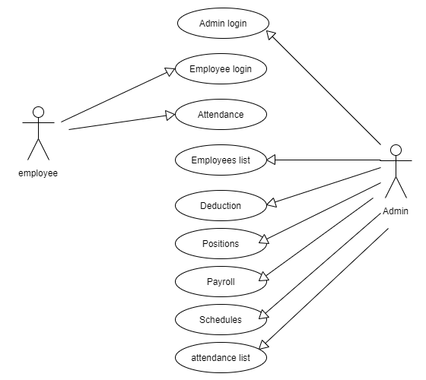

**Data flow Diagram for Payroll Management System:**

A data flow diagram is a graphical view of how data is processed in a system in terms of input and output. The Data flow diagram (DFD) contains some symbols for drawing the data flow diagram.

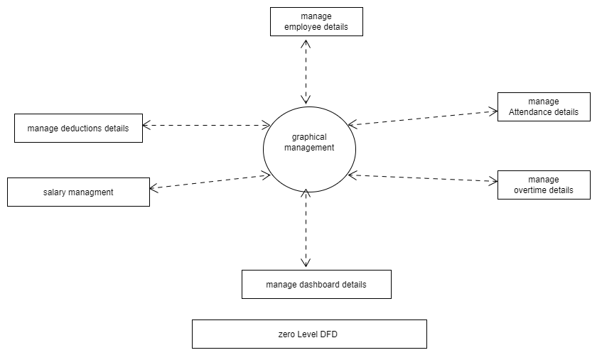

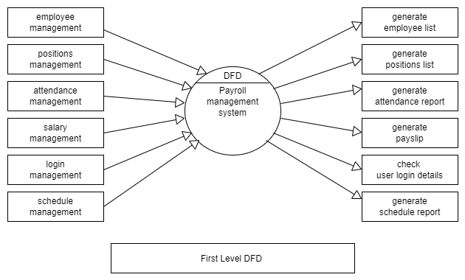

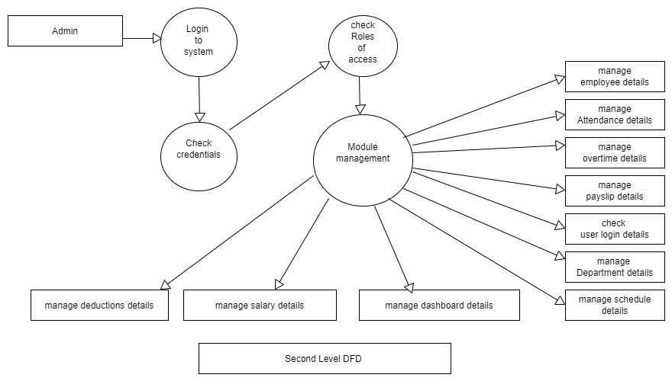

# Activity Diagram for payroll Management System: Hospital Management System Project The activity diagram used to describe flow of activity through a series of actions. Activity diagram is an important diagram to describe the system. An activity diagram shows the overall flow of control.

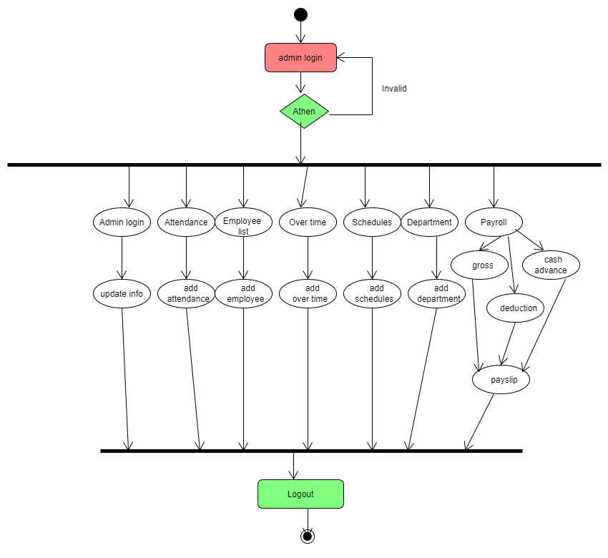

**Class Diagram for Payroll Management System**

A Class is a category or group of things that has similar attributes and common behavior. A Rectangle is the icon that represents the class it is divided into three areas. The upper most area contains the name, the middle; area contains the attributes and the lowest areas show the operations. Class diagrams provide the representation that developers work from. Class diagrams help on the analysis side, too.

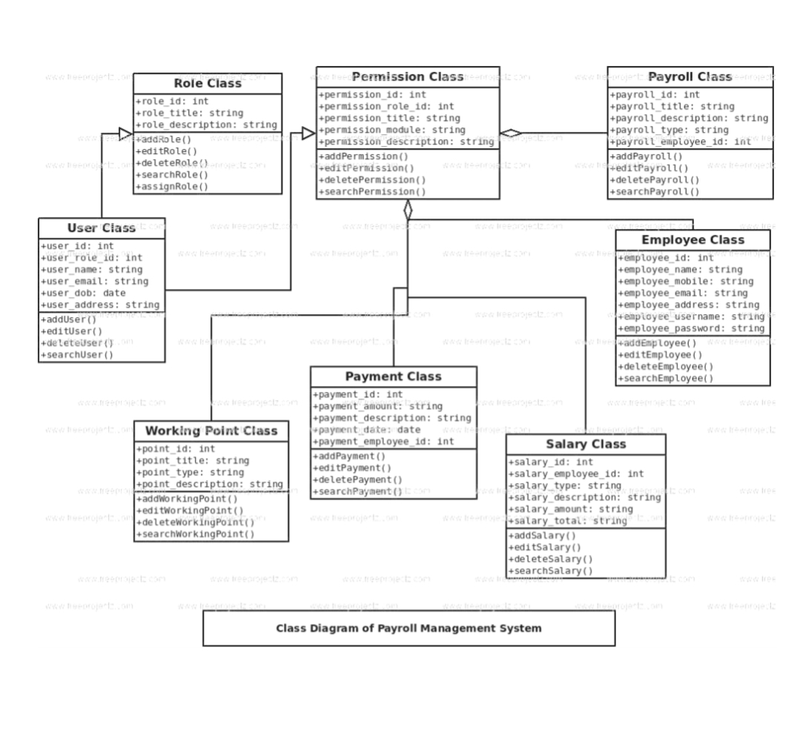

# Deployment Diagram for Payroll Management System:

# A Deployment Diagram shows the configuration of run-time processing nodes and the components that live on them. Deployment diagrams address the static deployment view of architecture. They are related to component diagrams in that a node typically encloses one or more components.

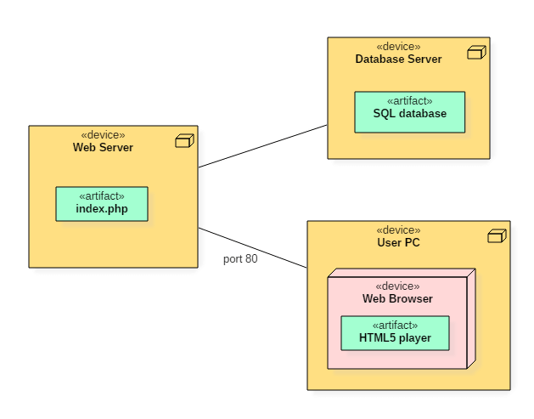

**Entity Relationship Diagram for payroll Management System**

Database is absolutely an integral part of a software system. To fully utilize ER Diagrams in database engineering guarantee you to produce high quality database design to use in database creation, management and maintenance. An ER model also provides a means for communication.

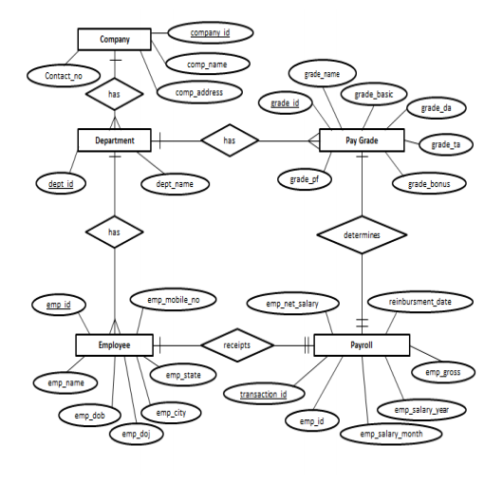

### Component diagram: it represents a set of components and their relationships. These components consist of classes, interfaces or collaborations.So Component diagrams represent the implementation view of a system.During design phase software artifacts (classes, interfaces etc) of a system are arranged in different groups depending upon their relationship. Now these groups are known as components.Finally, component diagrams are used to visualize the implementation.

### 

### Sequence diagram: A Sequence Diagram is an interaction diagram that emphasizes the time ordering of messages; a collaboration diagram is an interaction diagram that emphasizes the structural organization of the objects that send and receive messages. Sequence diagrams and collaboration diagrams are isomo byrphic, meaning that you can take one and transform it into the other

### 

### Testing:

**System testing and Implementation**

**Objectives of System Testing:**

Testing is an activity to verify that a correct system is being built and is performed with the intent of finding faults in the system. However not restricted to being performed after the development phase is complete but this is to carried out in parallel specification. Testing results, once gathered and evaluated, provide qualitative indication of software quality and reliability and serve as a basis for design modification if required a project is set to be incomplete without proper testing. System testing is process of checking whether the development system is working according to the original objectives and requirements. The system should be tested experimentally with test data so as to ensure that the system works according to the required specification. When the system is found working, test it with actual data and check performance.

Software testing is a critical element of software quality assurance and represents the ultimate review of specification, design and coding. The increasing visibility of software as a system element and the attendant â€œcostâ€ associated with a software failure is motivating forces for a well planned, through testing.

**Testing Principles:**

All tests should be traceable to customer requirements. The focus of testing will shift progressively from programs. Exhaustive testing is not possible. To be more effective, testing should be one, which has probability of finding errors.

**The following are the attributes of good test:**

* + A good test has a high probability of finding an error.
  + A good test is not redundant.
  + A good test should be best of breed.
  + A good test should neither too simple nor too complex.

**Levels of Testing**

The details of the software functionality tests are given below. The testing procedure that has been used is as follows:

* + **Unit Testing**
  + **Integration Testing**
  + **Validation Testing**
  + **Output Testing**
  + **User acceptance system**
  + **Performance Testing**

1. **Unit Testing**

The first level of testing is called as Unit testing. Here the different modules are tested and the specifications produced during design for the modules. Unit Testing is essential for verification of the goal and to test the internal logic of the modules. Unit testing was conducted to the different modules of the project. Errors were noted down and corrected down immediately and the program clarity as increased.

The testing was carried out during the programming stage itself. In this step each module is found to be working satisfactory as regard to the expected output from the module.

1. **Integration Testing**

The second level of testing includes integration testing. It is a systematic testing of constructing structure. At the same time tests are conducted to uncover errors associated with the interface. It need not be the case, that software whose modules when run individually and showing perfect results will also perfect results when run as a whole. The individual modules are tested again and the results are verified. The goal is to see if the modules can be integrated between modules. Poor interfacing may result in data being lost across an interface causing serious problems. This testing activity can be considered as testing the design and emphasizes on testing modules interactions.

1. **Validation Testing**

The next level of testing is validation testing. Here the entire software is tested. The reference document for this process is he requirement and the goal is to see if the software meets its requirements. The requirement document reflects and determines whether the software functions the user expected. At the culmination of the integration testing, software is completely assembled as a package, interfacing and corrected and a final series of software test and validation test begins. The proposed system under construction has been tested by Using validation testing and found to be working satisfactory.

1. **Output testing**

The output of the software should be acceptable to the system user. The output requirements are defined during the system analysis. Testing of the software system id done against the output requirements and the output testing was completed with success.

1. **User acceptance system**

An acceptance test has the objective of selling the user on the validity and reliability of the system. It verifies that the systems procedures operate to system specification and make the integrity of vital data is maintained.

1. **Performance Testing**

This project is a system-based project, and the modules are interdependent with the other modules, so the testing cannot be done module by module. So the unit testing is not possible in the case of this driver. So this system is checked only with their performance to check their quality. In case of the Unit testing the initialization module is first tested. Since read module and the write module is interdependent the performance testing is done only after the final phase of coding.

### References and Bibliography:

* + <http://www.bluedart.com/>
  + <http://www.wampserver.com/en/>
  + <http://www.php.net/>
  + <http://www.tutorialspoint.com/mysql/>
  + httpd.apache.org/docs/2.0/misc/tutorials.html

**TEAM MEMBERS : (CSE – F)**

**P.KALI PRASAD BABU AP18110010329**

**N.TARUN KUMAR AP18110010332**

**K.ROHITH AP18110010336**